Administrator
for St James in the City and Liverpool Next Generation

Employer: St James in the City, Liverpool
Salary: £20500
Hours: 37.5 (could be open to job share or flexible hours)
Predominantly 9-5pm with some Sunday involvement.
Location of workplace: St James in the City & home based
Duration of contract: 3 year period, potentially to be extended. Initial 6 month probation period.
Holidays: 25 days pro rata + bank holidays
Reports to: Operations Manager, St James in the City
Start date: Monday August 22nd 2022
Purpose of role:
This is a pioneering role, within a growing Church, with the aim of supporting the missional engagement of St James in the City Church (StJ) and Liverpool Next Generation (LNG).

StJ is an Anglican Church in the city centre of Liverpool. It was commissioned 2007 to connect with all aspects of city life and has an aspiration to be a large resourcing church for the city of Liverpool. We are passionate about seeing God’s kingdom built on earth by being a bigger church making a bigger difference. StJ is the lead church within the LNG network.

In 2020 the diocese of Liverpool commissioned the LNG project to ensure that every year significant numbers of 11-29 year olds are coming to faith, growing in faith and making a difference for Jesus. The LNG Missional Chaplains and their teams are working across Liverpool University, Liverpool John Moores University and three secondary schools – St Hilda’s, Archbishop Blanch and St Margaret’s.

In the first 2 years of the LNG project (launched mid-pandemic) we have seen over 100 students land in church community, multiple interactions with every pupil across our 3 schools. We have run Alpha on University of Liverpool campus and in 2 of our 3 schools plus regular discipleship groups every week in each school. We have held various youth events which have had great attendance from the pupils we have interacted with in schools.

This administrator post is focused on bringing excellent communication, interpersonal skills, reporting skills, organisation and planning activity to the day to day management of StJ with a specific focus on taking the administrative burden away from frontline mission workers of the LNG teams. A significant amount of written material including reporting on numbers is also required, and the administrator will need to have excellent IT skills with creative production ability.

This job is based within the StJ staff team, and will include supporting the wider administrative staff, facilitating the growth of 11-29 year olds within the St James’ community as well as integrating the work of the LNG teams into StJ and the other LNG local churches. Examples of work activities are given below.

Social Media oversight: engagement with wider team to define social media plan, liaising with creative team and ministry leaders to produce content and taking a lead on posting and scheduling.

Communication and interpersonal: regular and effective communication to team and volunteer base, management of volunteers and implementing safeguarding practices and conducting DBS checks, facilitation and minute taking in meetings, creation of promotional material distribution etc.

Production of resources: write up and production of mission and discipleship resources, engagement in review process and write up of termly and annual reports etc.

Administration: maintaining the social media pages, collection and storage of weekly attendance data, supporting the chaplains with expenses and team budgets, production of weekly and termly newsletters etc. General administration support to the Vicar and Operations Manager.

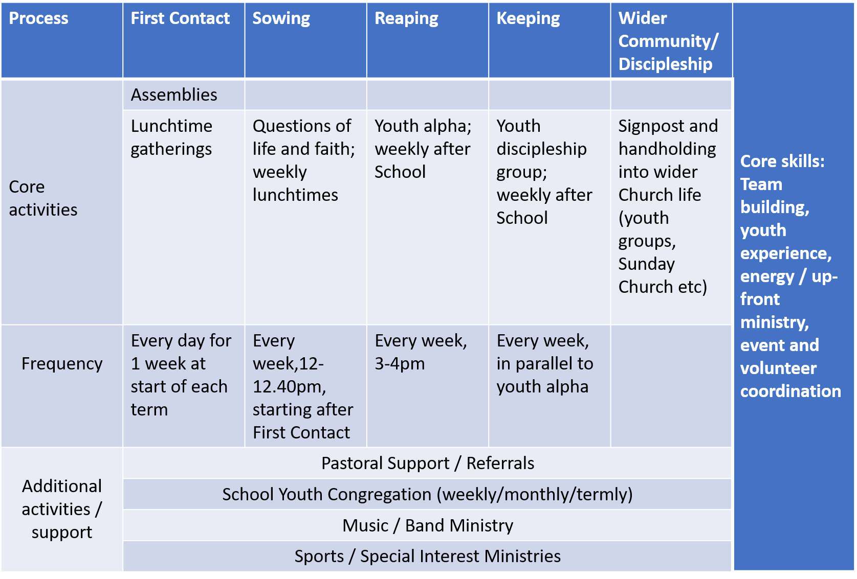
Below are the current missional models for both the school and university missional teams.
Discipleship Pathways
Current School’s Missional Model:

Current University Missional Model:

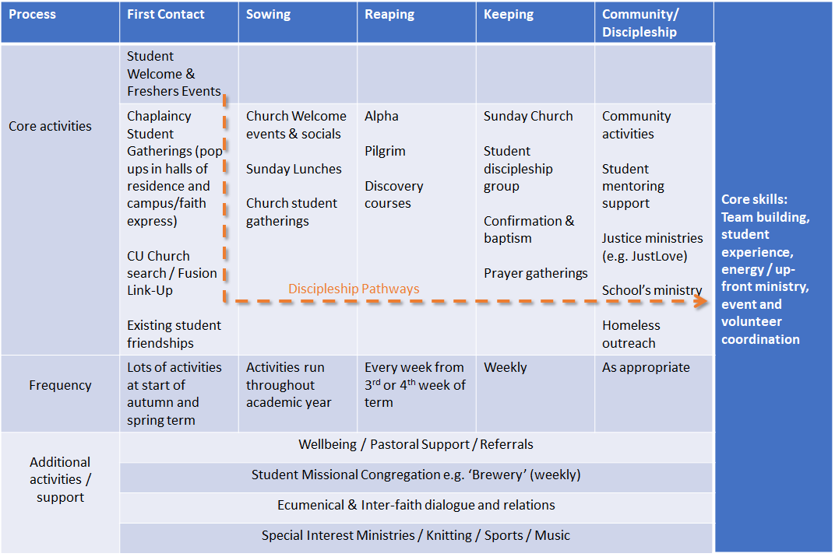

What we are looking for:
A very capable administrator, experienced in social media, with a heart for mission, young people and the growth of the church.
Person Specification:
Each of the following criteria will be assessed via: (a) application form; (i) interview

 | Essential Requirements | Desirable Requirements
Qualifications |  | Degree level education and/or relevant administrative qualification (a)
Spiritual & Personal | A person of integrity who can keep absolute confidentiality (a/i)  Ability to take responsibility to ensure tasks are completed (a/i)  Good with detail, a completer/finisher, but also able to facilitate the work of others (a/i)  A proven problem solver with resilience and flexibility (a/i)  Openness about areas of personal formation / ongoing development and a willingness to engage in training where appropriate (a/i)  A committed Christian with a passion to see people come to Jesus and grow in faith (a/i) | A member of the Church of England (a)
Administration | A person who can communicate well and has excellent interpersonal skills. Working well within a team and being persistent to ensure that the work gets done (a/i)  Ability to organise and plan events and activities, with significant numbers of paid and volunteer workers contributing, to reach large numbers of young people (a/i)  Ability to produce good written documentation and to engage positively and helpfully in regular review processes (a/i)  Personal interest and use of social media (a/i) | Proven experience of team building in a ministry context (a/i)  Proven experience working with social media (a/i)
Knowledge and Skills | Able to prioritise tasks and manage own performance (a/i)  Good personal organisation and administration skills (a/i) | Experience of working in a Church context (a/i)  Knowledge of the structures and organisation of the Church of England (a/i)

Closing Date for Applications: 19th June 2022
Interview Date: 8th July 2022 (can be re-arranged if needed)

For an informal chat for further information, please contact Janet Wightman (janet.wightman@stj.org.uk, 07772445216)

StJ & LNG – Administrator
Application Form

Personal Information

Name (First / M / Last)

Address

Email Home Phone

Mobile Phone

Qualities & Qualifications

My primary qualities are:

My Hobbies and interests are:

My formal education, training and qualification includes:

Character and Ability

How would you describe your work ethic?

Please give examples of times you have used your communication and organisation skills

Please give examples of your social media use

Please describe times you have had to….

be responsible:

use integrity:

overcome a problem:

What 5 words do you think a colleague would use to describe you?

- 2. 3. 4. 5.

What 5 words do you think a friend would use to describe you?

1. 2. 3. 4. 5.

Experience

Please tell us about your administrative experience (please include examples of using social media, report writing, and event planning)

Please describe times you have worked well on your own and times you have worked well in a team.

If applicable, please give us examples of working either with schools and/or universities

If applicable, please give us examples of working in a church context

Faith

Please tell us about your experience of Faith and Church?

If applicable, please tell us about any Church of England experience you may have.

Final thoughts

What do you feel you could bring to the team?

Why would you like to join the StJ & LNG team?

Policy Statement
Our policy is that all team members must provide two references. If applicable, please provide a church leader reference (Other references may be taken up if required). A full DBS may also be undertaken.

Please give details of your Referees

Length of time known:

Capacity:

Name:

Address:

Postcode:

Email:

Phone:

Length of time known:

Capacity:

Name:

Address:

Postcode:

Email:

Phone:

Criminal record
Please give details of whether you have had a criminal conviction, caution, reprimand or final warning in this country or any other country. Please state whether you have a police enquiry or prosecution pending in this or any other country. This position is exempt from the rehabilitation of offenders act 1974 and you are required to disclose all conviction, cautions, reprimands or final warnings including those that have become spent for driving offences, please only answer yes if it resulted in a disqualification.

YES NO

Child protection
Has your conduct ever caused mental or physical harm to a child or put a child at risk? To your knowledge has it ever been alleged that your conduct has resulted in any of these things?

YES NO

St James in the City will comply with all safer requirement and any offer of employment is conditional on receiving satisfactory information from all the necessary checks. Furthermore, your personal data will be treated as strictly confidential and we will follow all the necessary GDPR. If your application is not successful, your data will be held for 6 months after the recruitment process ends, and then destroyed.

Please indicate that you have read this section and understood YES NO

SIGNATURE DATE

Please post or email to:

Janet Wightman
4 Lady Chapel Close
Liverpool
L1 7BZ
Janet.wightman@stj.org.uk
07772445216

